1. **About Us**

**Artshoily** is your platform for buying and collecting art. The name suggests a fusion of art with a distinctly Bangladeshi cultural essence, drawing from the word *"shoily"* (meaning style or approach in Bengali). Artshoily (pronounced as *"Art-shoy-lee"*) aims to provide a space where artists can showcase their work, and collectors or enthusiasts can discover, purchase, and support local and emerging talent.

At Artshoily, we focus on quality and thoughtful curation, offering a carefully selected collection of paintings, drawings, limited edition prints, sculptures, digital art, traditional crafts, tribal art, rare collectibles, and unique artifacts. Each piece is sourced from trusted artists, designers, and collectors, ensuring authenticity and cultural depth. Whether you're discovering a statement piece or a hidden gem, Artshoily is your gateway to celebrating the rich artistic heritage of Bangladesh and beyond.

Artshoily’s services:

* **Marketplace for Art**: A curated space for fine art, traditional crafts, modern pieces, and digital artworks, focusing authentic artists from Bangladesh and other countries.
* **Cultural Identity**: Focusing on the unique cultural narratives of Bangladesh, tying in with themes that reflect the socio-cultural shifts as evidenced through the Bangladesh’s Gen Z movement of 2024 or historical student movements.
* **Artist Support**: A platform to empower artists, offering exposure and financial opportunities.
* **Collector Engagement**: Creating an engaging community for art lovers to explore and collect pieces that resonate with them.

1. Replace this with the text below: 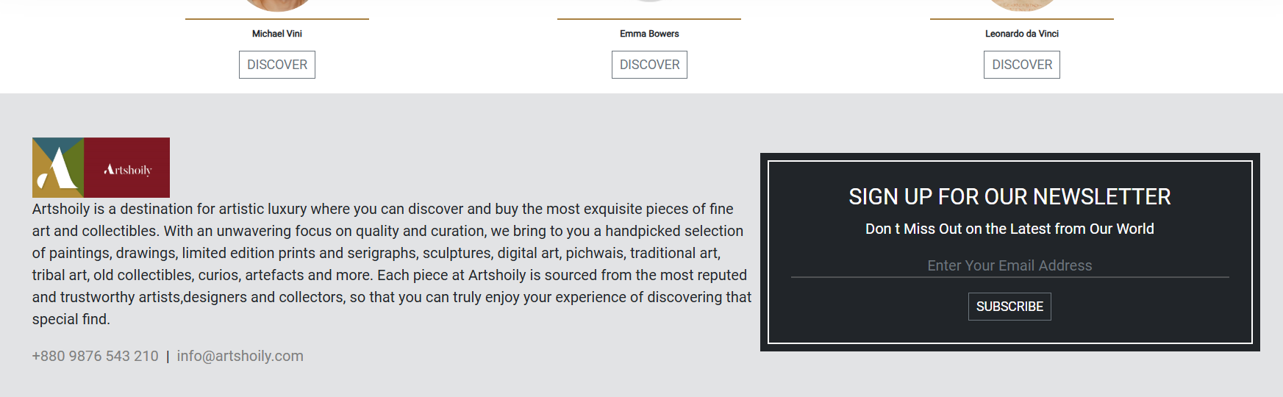

Artshoily is your trusted source for authentic art collections, where you will discover a perfect blend of aesthetics and artistic sensibilities. We are committed to promoting and supporting artistic talent, offering genuine pieces of art and collectibles from a diverse range of artists and verified sources.

At Artshoily, you will find artworks by both celebrated and emerging artists, whose creations are meticulously curated to appeal to your aesthetic buds and bring you the true joy of artistic appreciation.

1. MORE OF HIS DESIGN should be replaced by MORE OF THE ARTIST’S WORK:

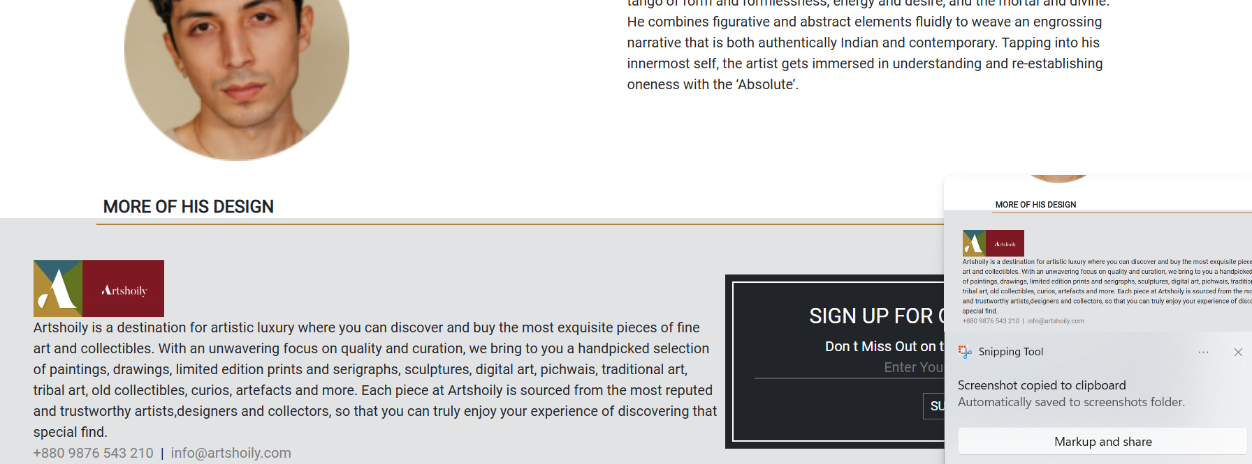

This is applicable for multiple places.



Are the BLOG LOGIN and SEARCH functionalities currently operational? I do not believe they are working as intended. We need to review these pages along with their corresponding templates to ensure they are properly integrated.

Additionally, can you confirm whether these functionalities are included in the database schema? The SEARCH feature should support wildcard searches for better usability.

1. The hyperlinks on the artworks or name are not currently activated. We should activate hyperlinks on the images and name of the artists.

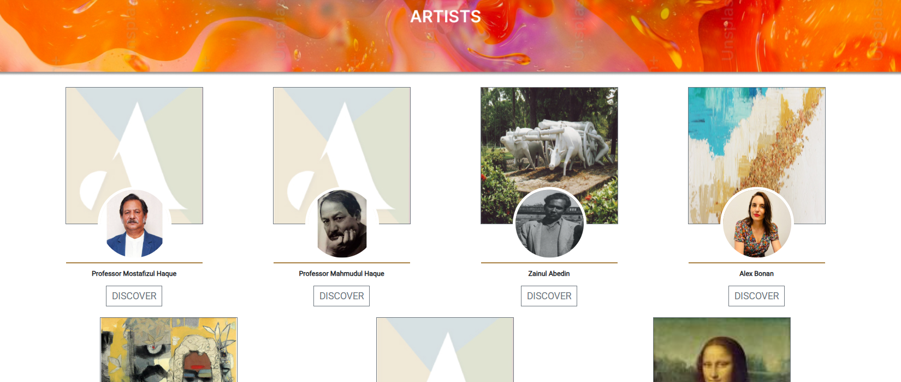

1. The FILTER options are currently not functional. Please kindly make it functional in all pages and share the templates for FILTER options and how we are going to do this.

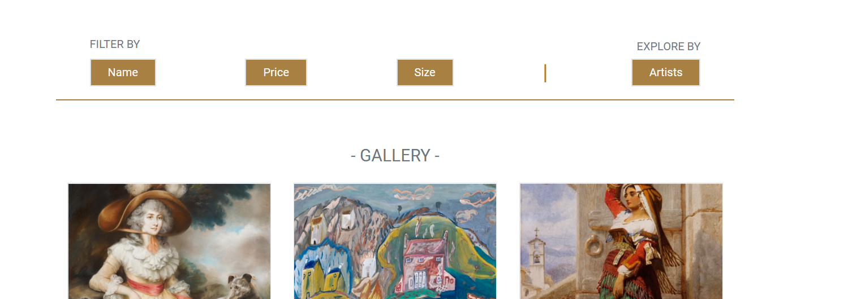

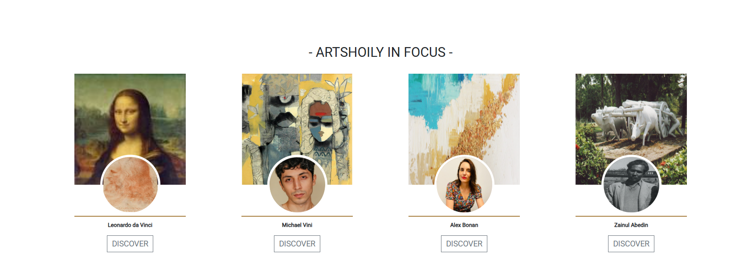

What are we planning for this item- “**ARTSHOILY IN FOCUS**”? Will it feature in media outlets, a review journal, or serve another purpose? Currently, I can only see the artworks, but there doesn’t appear to be a template or prelude that links to any media or journal. Could you clarify the intended direction for this feature?

1. I observe that the landing or homepage includes the following sections:
2. DISCOVER OUR WORLD
3. INSPIRED COLLECTIONS
4. LIMITED EDITION PRINTS
5. ARTSHOILY IN FOCUS
6. CLIENT STORIES
7. SCULPTURES
8. PARTNERS AND CLIENTS
9. LATEST FROM OUR BLOG

All of these sections need to be fully functional in the prototype or the first sharable version of the website and integrated into the database schema. I will provide the necessary texts, if needed or applicable for these sections in the next iteration, inshaAllah.

**That’s all for now! I will give more comments on the specific items, particularly on the landing or home page.**